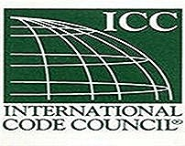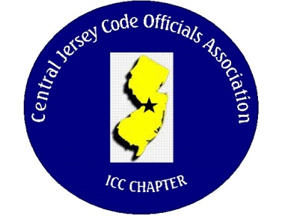CJCOA

Central Jersey Code Officials Association

Call to Order: President John White called the meeting to order on October 2, 2024 at 12:05 pm with 32 in attendance.

Guest Speaker: Cassidy Brummel from Insultex

Approval of Minutes: Minutes were approved.

Correspondence: None

Treasurer’s Report: Read by Treasurer Nick Van Wagner

Legislative Report: None

Finance & Audit Committee. No Report

Education Committee: Our November guest speaker will be Steve Long from E.R. Long & Associates who will presenting weep screeds for exterior plaster stucco and adhered masonry installations.

Membership Committee: Members who are paid in full to date. 126

Life Members. 23

Associate members: 3

By-Laws Committee: No Report

Historical Committee: No Report

Good & Welfare Committee: Domenic Cardarelli had (2) hips replaced and is doing great. Tony Cermele had heart surgery and Ed Allat’s (Hillsborough FSC) wife had heart surgery also.

Public Relations: Facebook

Code Change Committee:

Building: The subcode committee has completed their code review.

Electric: The second round of hearings are this month, and the 2026 NEC has moved some things around.

Plumbing: No Report

Fire: The committee has gone over code changes. The Division of Fire Safety Proposal PRN 2024-093 needs comments by 10/4. The following items were in the proposal Combination Fire/Smoke Damper, Dedicated Smoke Control and Fire Damper Installer and Inspector Certification.

R324.6 (Pathways will be a joint review between Electric and Fire with Electric having inspection responsibilities. 3.4(a)6 PRN 2024-106 requires comments to be submitted by 11/15.

Nominating Committee: 2025

Scholarship Committee: The applications are online @ cjcoa.org. Deadline for applications is November 1.

Website Committee: cjcoa.org

Golf Committee: Our next golf outing will be June 5, 2025

Ad-Hoc:

DCA: No Report

ICC: The ICC Conference will be in Long Beach California October 21-22.

ICC-Region 7: No Report

Unfinished Business: None

New Business: The executive board is discussing the possibility of supporting NJBOA again

Announcements: Trenton is looking for a PT or FT Plumbing Subcode Official. Montgomery Township is looking for a PT Plumbing Inspector. Warren Township is looking for a PT Building Inspector. The Barrier Free codes have very little changes.

Meeting was adjourned: 2:50

Respectfully Submitted,

Frank Oliveti

Secretary